**Mobile ICP-1**

**Code:**

1.At first we have given the credentials of email and password in Main Activity the email id as yamini.saraswathi1997@gmail.com and password as yamini@123

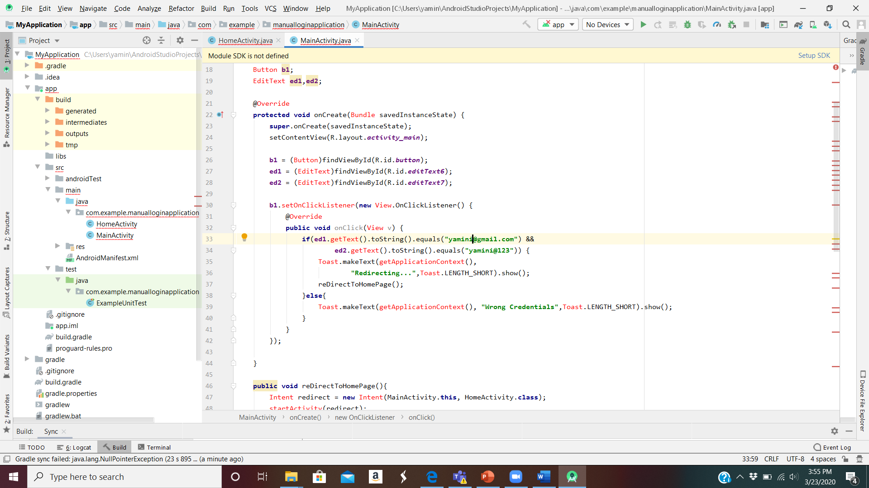

2.The Home Activity page when clicking on it again redirects back to the Main page

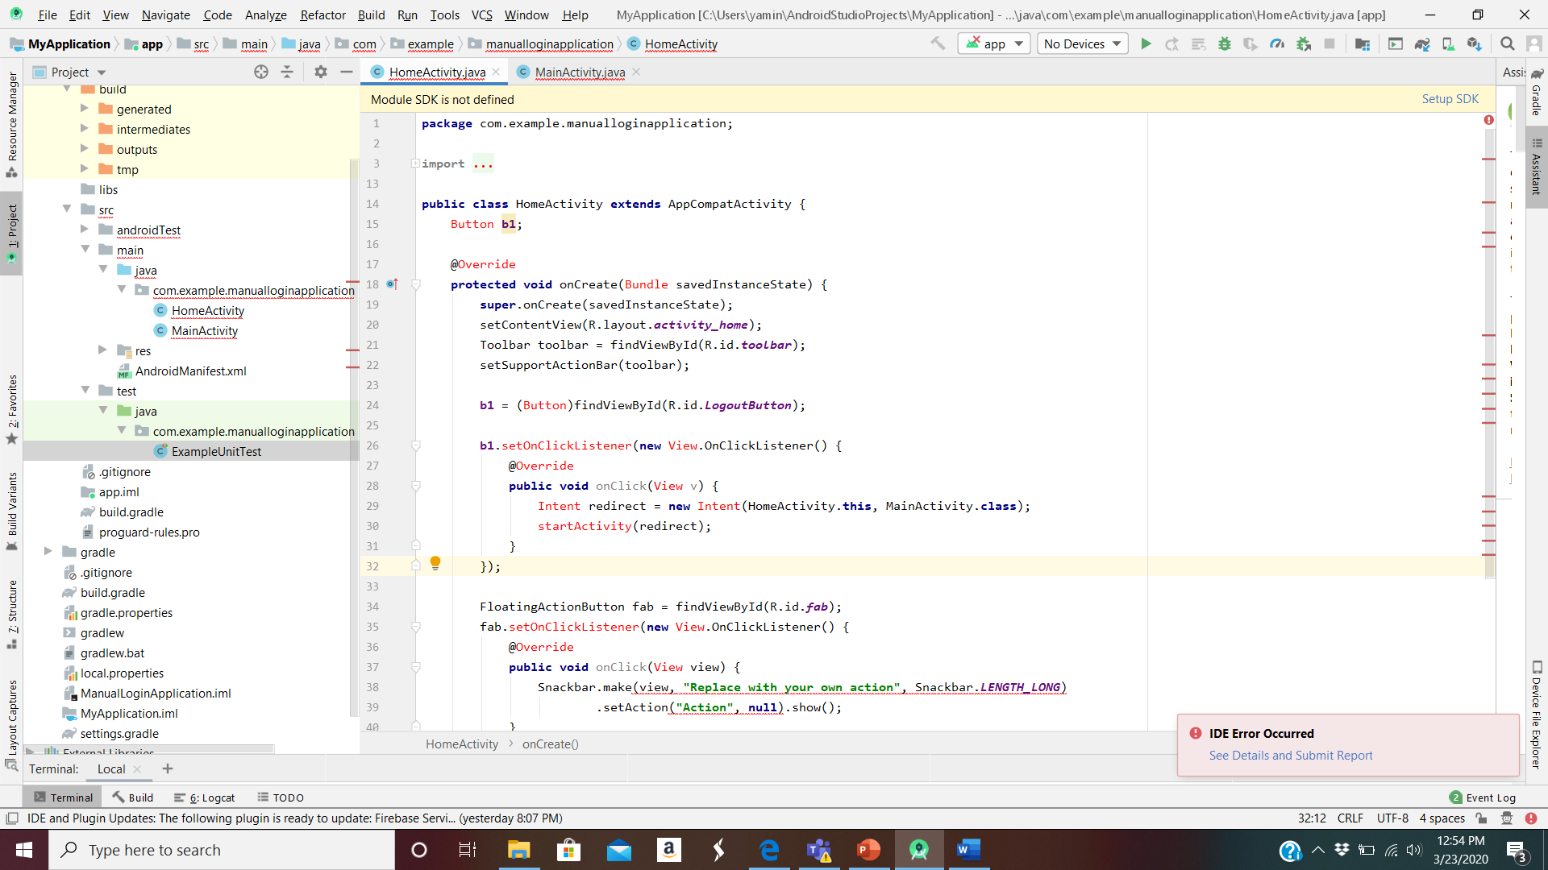

**Workflow:**

1.Entering the credentials

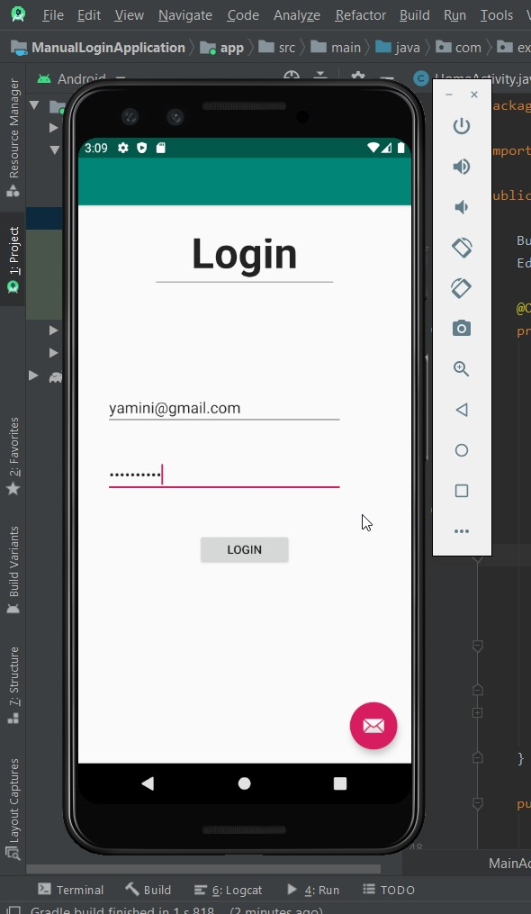

2. After Logging In

